Relational Diagram Report

The Schema Diagram is mapped from EER diagram from the PART 1 following the rules of mapping. The Schema Diagram is
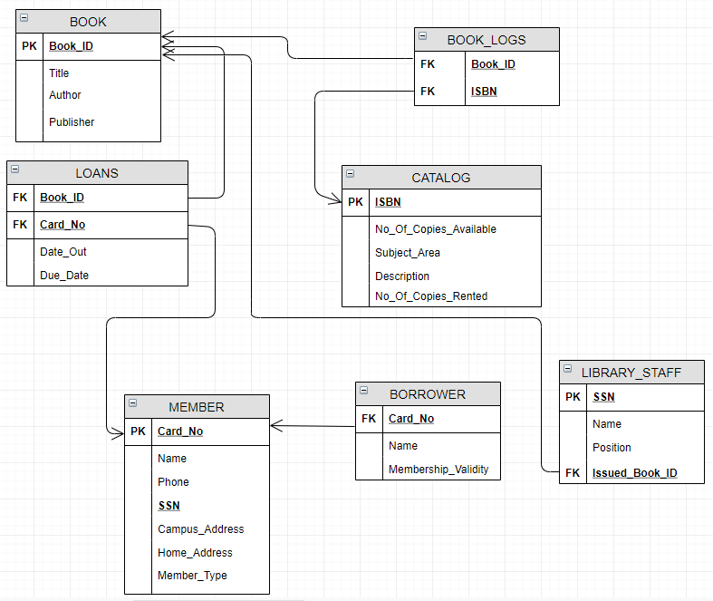

The Assumptions for choosing the Tables and the attributes were stated in the documentation report of PART 1.
Create Table statements along with the Referential Integrities are kept in a text file “Create_Tables(Library).sql”.
The spooling was done for the creation of tables and are stored in a text file “SPOOL_TABLES.txt”.
The choices we made during the EER-to-relational mapping and the reason for the choices:
- BOOK:
Attributes:
- Book_ID (Primary Key)(project description)
- Title (Project Description)
- Author (Project Description)
- Publisher (Project Description)

- CATALOG:
Attributes:
- ISBN (Primary key)(Project Description)
- No_Of_Copies_Available (Project Description)
- Subject_Area (Project Description)
- Description (Project Description)
- No_Of_Copies_Rented (Project Description)

- BOOK_LOGS:
Attributes:
- Book_ID (Foreign key)( which maps to the primary key Book_ID of BOOK)
- ISBN (Foreign key)( which maps to the primary key ISBN of CATALOG)

- MEMBER:
Attributes: Reasons for assumptions showed in PART 1
- Card_No (Primary key)(assumed)
- Name (project description)
- Phone (project description)
- SSN (project description) (UNIQUE KEY)
- Campus_Address(project description)
- Home_Address (project description)
- Member_Type (project description)

- LOANS:
Attributes:
- Book_ID (Foreign key) (Step:4 Mapping of Binary 1:N Relationship type)
Reason: As LOANS and BOOK have 1: N Binary relationship (refer EER diagram) we include Book_ID as foreign key in the LOANS which maps to the primary key Book_ID of BOOK.
- Card_No (Foreign key) (Step:4 Mapping of Binary 1:N Relationship type)
Reason: As MEMBER and LOANS have 1: N Binary relationship (refer EER diagram) we include Card_No as foreign key in the LOANS which maps to the primary key Card_No of MEMBER.
- Date_Out (project description)
- Due_Date (project description)

- BORROWER:
Attributes:
- Card_No( Foreign key) (Step:3 Mapping of Binary 1:1 Relationship type)
Reason: As MEMBER and BORROWER have 1:1 Binary relationship (refer EER diagram) we include Card_No as foreign key in the BORROWER which maps to the primary key Card_No of MEMBER.
- Name (project description)
- Membership_Validity (project description)

- LIBRARY_STAFF:
Attributes:
- SSN (Primary key) (project description)
- Name (project description)
- Position (project description)
- Issued_Book_ID (assumed) (Foreign key) (Step:4 Mapping of Binary 1:N Relationship type)
Reason: As LIBRARY_STAFF and BOOKS have 1: N Binary relationship (refer EER diagram) we include Issued_Book_ID as foreign key in the LIBRARY_STAFF which maps to the primary key Book_ID of BOOK.

